**Document Assignment Github Python**

1. Clone Repository <https://github.com/muklisai/CS-Fundamental-DS.git>

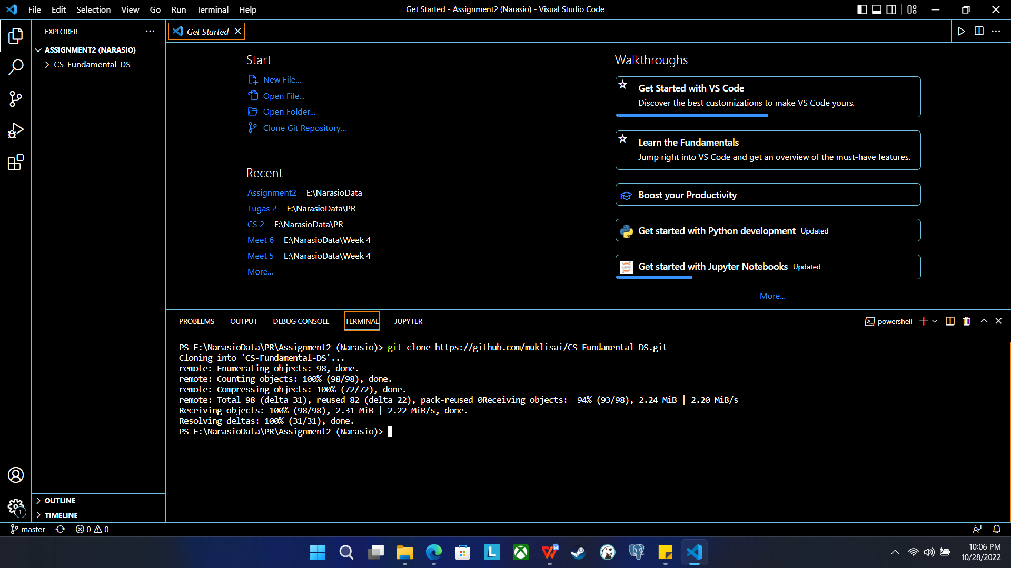

1. Create New Branch (add/novian)

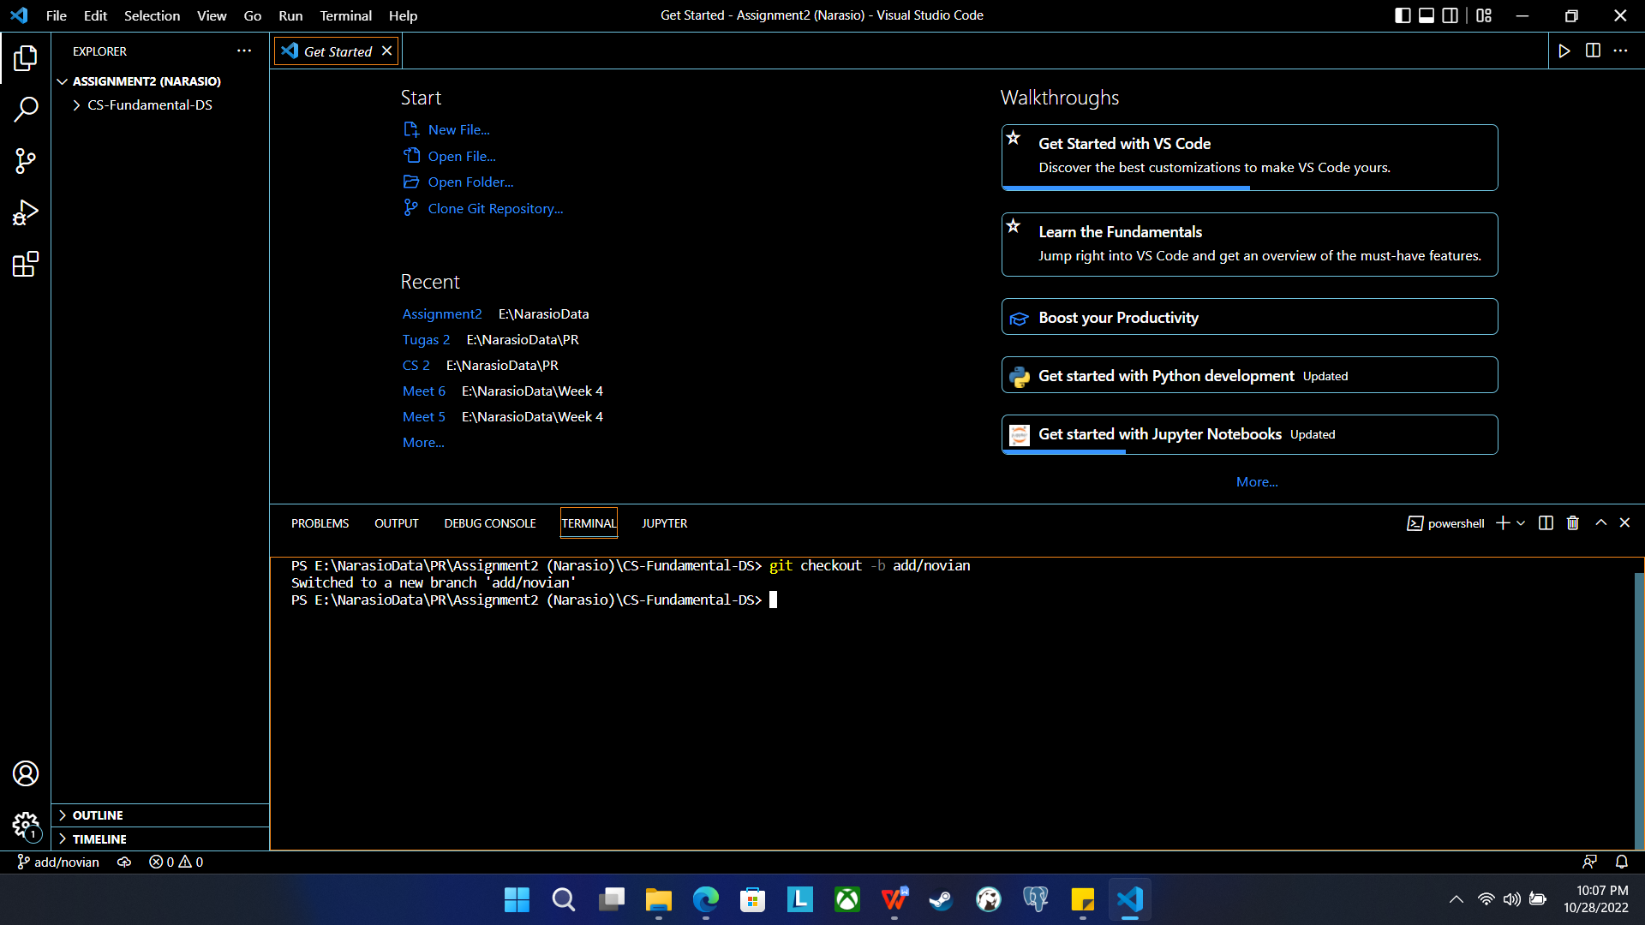

1. Git add new directory & file to branch add/novian

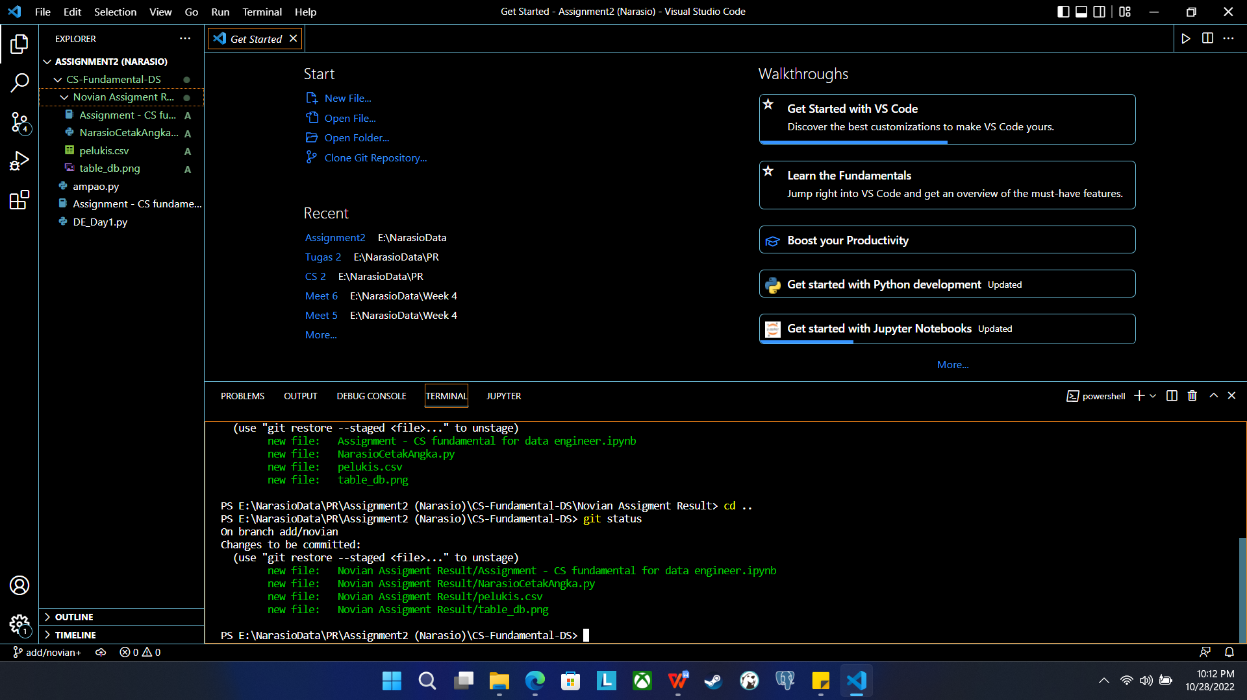

1. Commit file python to branch add/novian

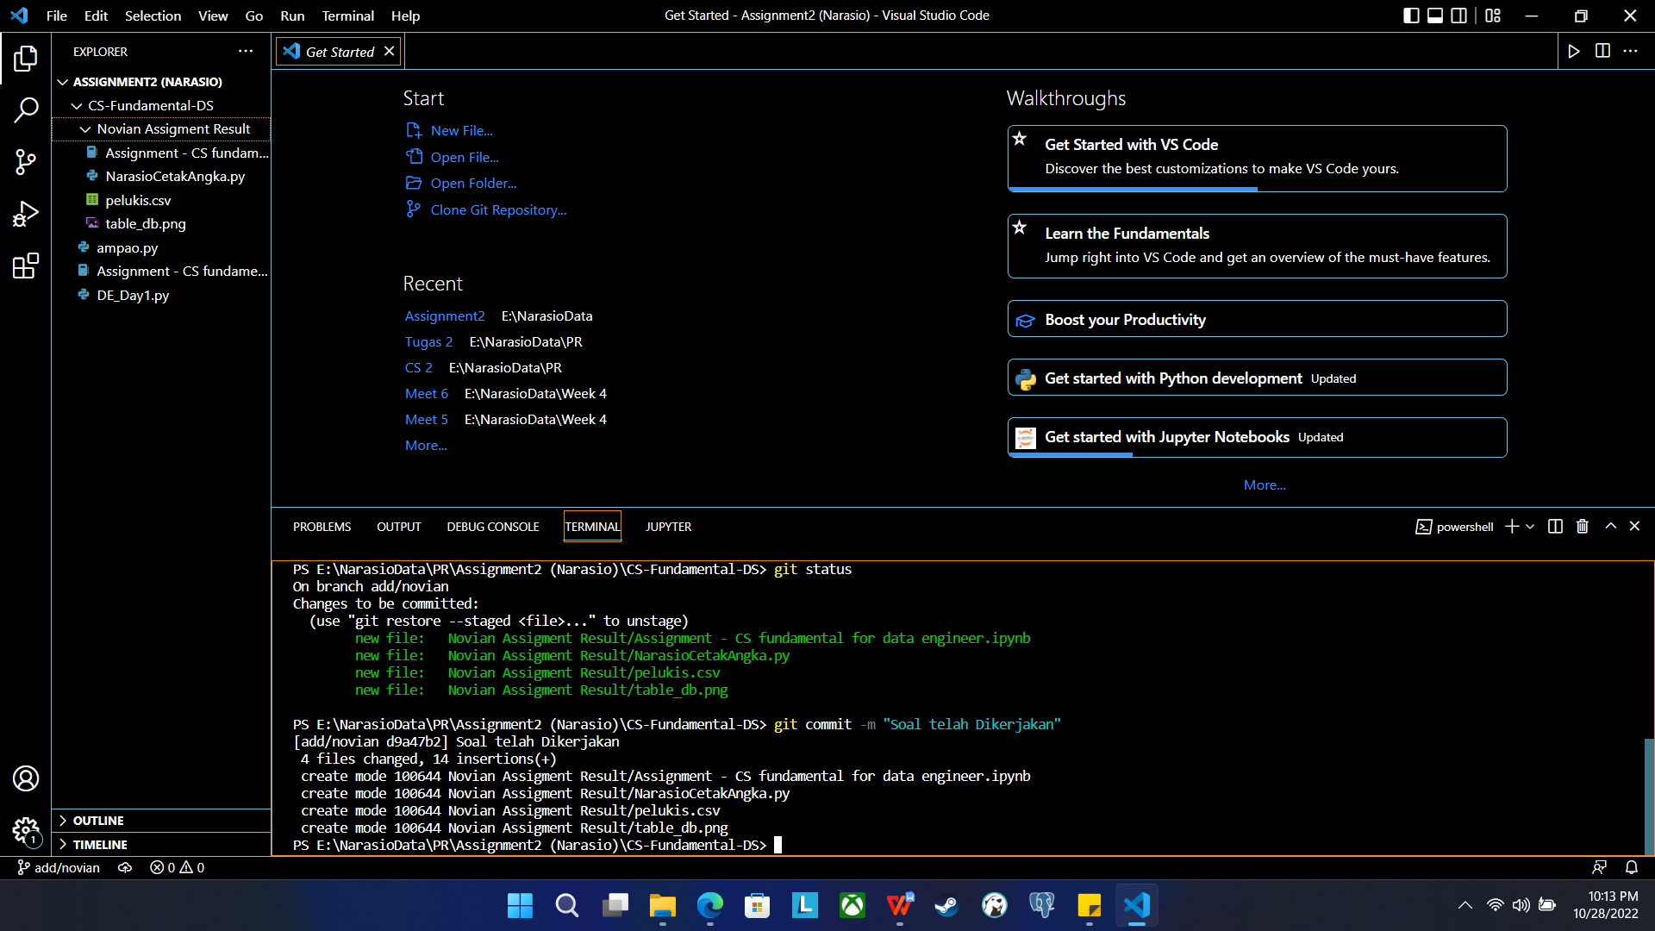

1. Push commit to branch add/novian

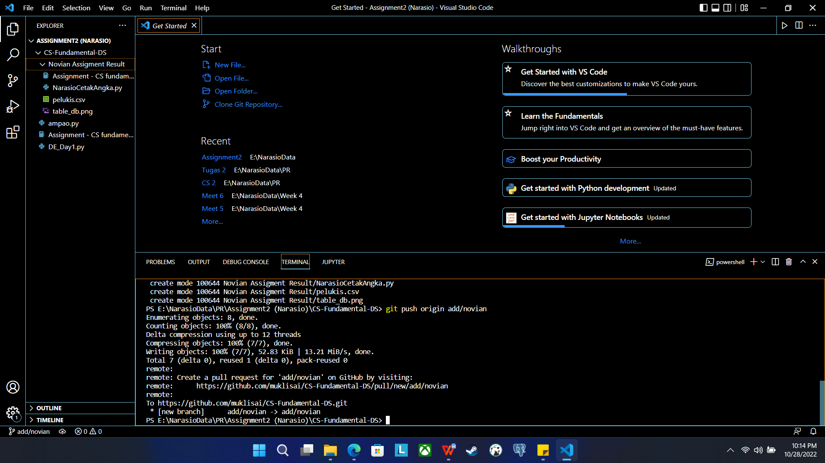

1. Modify File python

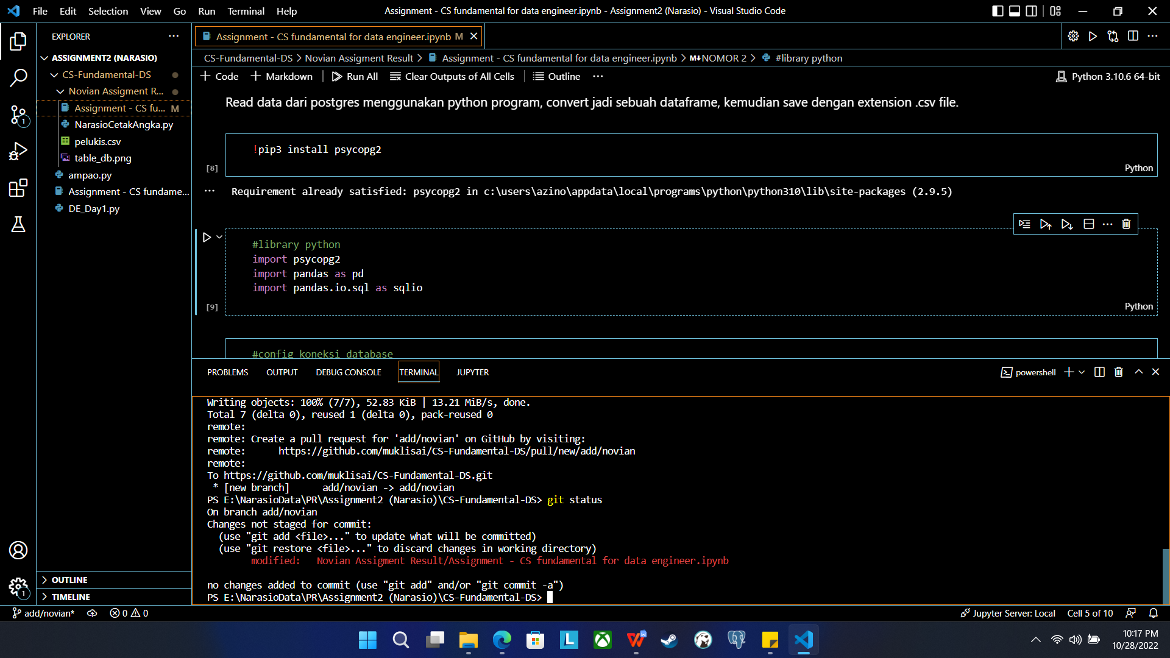

1. Add File modify to branch local add/novian

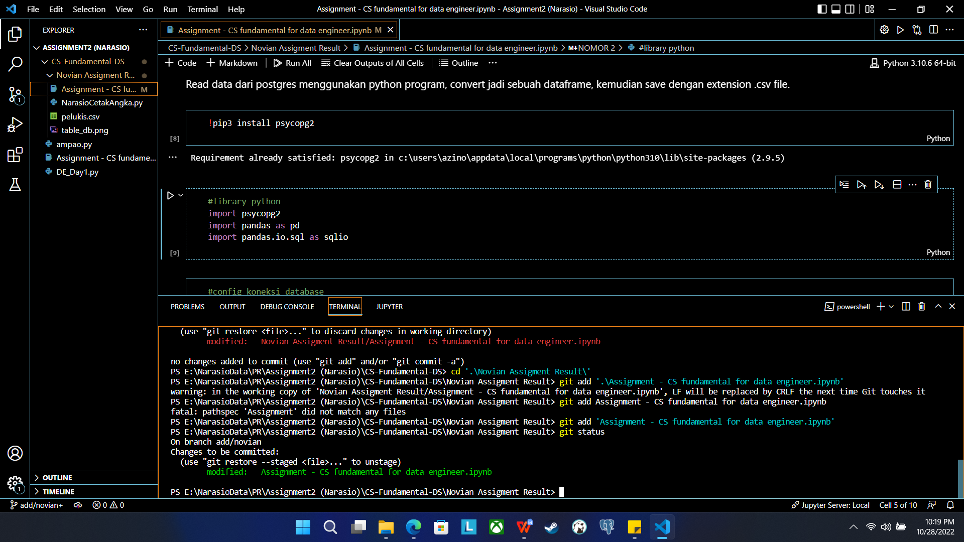

1. Commit & Push file modify to branch add/novian github

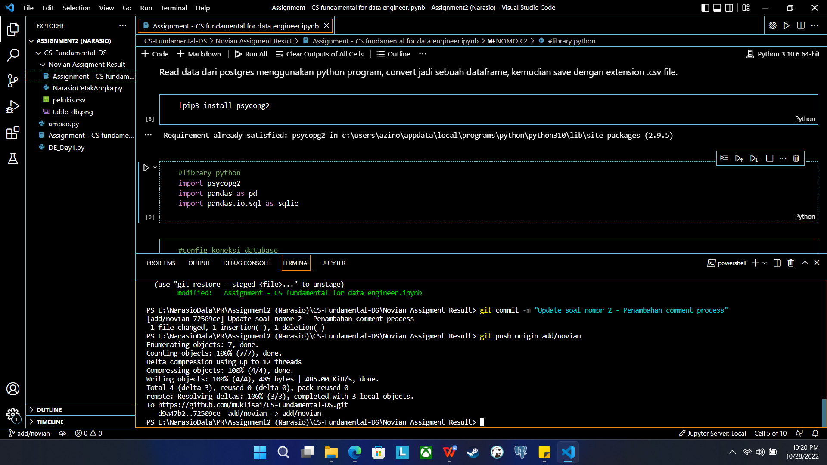

1. Repository Github branch add/novian

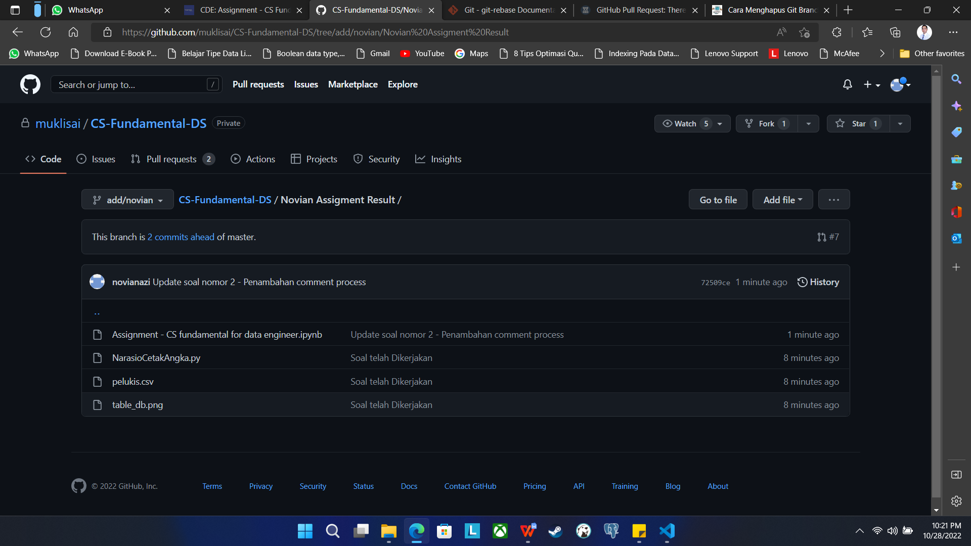

**Link Github : <https://github.com/muklisai/CS-Fundamental-DS.git>**

**Branch : add/novian**